Senior R&D 2nd Fail ***prototype evaluation*** Project grade is out of 200 pts

Due Date: ***2019Feb 25or 26th if school cancelation***

Group name **VisiStick**

Members Names **Seth Teichman, Kyle Ayers**

Each team must complete the following:

1. Make a new Presentation with the following : (10pts)

This should be an update to the previous (first fail presentation)

1. problem statement
2. milestones passed
3. all attempts at solving solution so far
4. physical models and or prototypes explained and what went wrong and right
5. costs so far in materials and labor so far (use $10 per hr per group member- DeSimony makes $40 per hr)
6. what the group is doing for the to remedy the issues to solve the problem statement
7. ***what each team member is going to be responsible for on the project for the next 2 weeks***
8. A working prototype! (30 pts)

Last 4 website updates. Dates and what was updated? (20pts)

1. Added Bearing and Mount to “Our Design” page on 12/19

2. Added Sensor Case to “Our Design” page on 12/19

3. Added Bearing and U-Mount to “Our Design” page on 12/21

4. Added Bearing and U-Mount V2 to “Our Design” page on 2/11

Last 4 GANTT chart updates. Dates and what was updated? (20pts)

1. Design New Case 2/7/19-2/15/19

2. Update Presentation to Make First Prototype Presentation 2/7/19-2/26/19

3. Purchase and Research Materials for New Case 2/18/19-2/25/19

4. Make New Case 2/26/19-2/28/19

Each members current obligation to the project and percentage complete as of Feb 25th or 26th (list each name, Job and percentage complete with validation via GANTT chart below) (20pts)

Seth – iPhone Programming – SUSPENDED (Custom app is unnecessary to demonstrate the concept in a prototype when we have a simple data readout instead)

Seth – Electrical Module – SUSPENDED (Electronics are unnecessary when we can run off of wall power for the prototype demonstration)

Seth and Kyle – Mechanical Design and Prototype – Parts Purchased, Construction Planned, Seth is working on this instead of Programming and Electrical because of priority

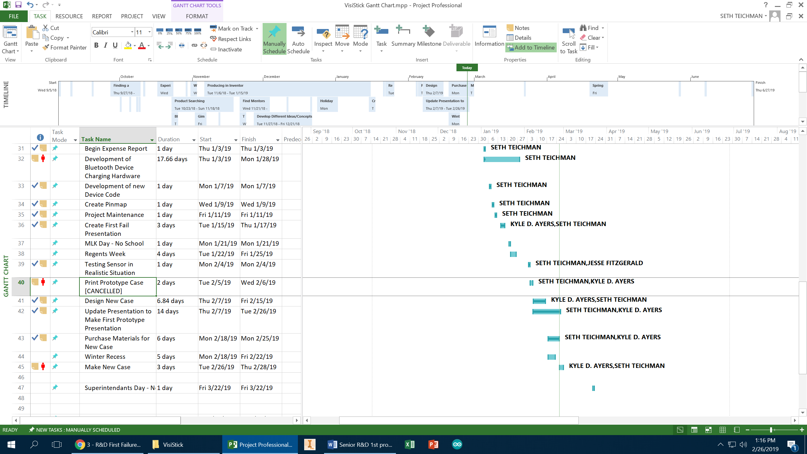

***Below to be filled out by Instructor***

Does the prototype address the Problem statement? YES NO (20pts)

Can the basic premise of the solution be demonstrated? YES NO (20pts)

Can all systems of the solution be demonstrated? YES NO (20pts)

Was informal presentation well executed? YES NO (20pts)

Did group explain what had to be done next to keep progressing on project? YES NO (20pts)